[Skip to content](https://www.theengineeringprojects.com/2016/11/examples-of-embedded-systems.html#content)

+92-300-4711820825, Al-Hafeez Shopping Mall, Main-Boulevard, Gulberg.theenggprojects

[Login](https://www.theengineeringprojects.com/wp-login.php)

[$ 00](https://www.theengineeringprojects.com/cart)

[Facebook](https://www.facebook.com/theengineeringprojects)[Twitter](https://twitter.com/syedzainnasir)[Google+](https://plus.google.com/+SyedZainNasir)[YouTube](http://youtube.com/theengineeringprojects)

The Engineering Projects

A lot of Engineering projects and tutorials for the students to help them in their final year projects and semester projects.

[](https://www.theengineeringprojects.com/)

* [Home](https://www.theengineeringprojects.com/)
* [Blog](https://www.theengineeringprojects.com/blog)
* [Forum](https://www.theengineeringprojects.com/forum/)
* [Projects](https://www.theengineeringprojects.com/2015/03/arduino-projects.html)
* [JLCPCB $2 PCBs](https://jlcpcb.com/)
* [Free PCB](https://www.pcbway.com/free_pcb.html?ad=TEP)
* [PCB Online-Ordering](https://www.wellpcb.com/pcb-quote)

Top of Form

Search: [Search](https://www.theengineeringprojects.com/2016/11/examples-of-embedded-systems.html#go)

Bottom of Form

**Real Life Examples of Embedded Systems**

**A step by step tutorial on Examples of Embedded Systems**

You are here:

1. [Home](https://www.theengineeringprojects.com/)
2. [Embedded Systems](https://www.theengineeringprojects.com/category/embedded-systems)
3. Real Life Examples of Embedded…

[](https://www.pcbway.com/project/free_shipping_pcba.aspx?from=TEP12)

[](https://www.theengineeringprojects.com/wp-content/uploads/2016/11/Examples-of-Embedded-Systems.jpg)Hello Friends, I hope you are fine and doing great in your lives. Today I am going to write an article on real life **examples of embedded systems**. These **Embedded Systems Examples** belong to real life appliances and devices, which we use in our daily routine. I hope you already have the idea of embedded systems but if you don’t then you can find the introduction to embedded systems in my previous article [What is Embedded System?](https://www.theengineeringprojects.com/2016/10/what-is-embedded-systems.html) And also you can go through [What is Embedded Computer?](https://www.theengineeringprojects.com/2016/10/embedded-computer.html) I have also shared few *Embedded Systems Examples* in this article. My article on [8 things for learning embedded system programming](https://www.theengineeringprojects.com/2016/11/things-learning-embedded-systems-programming.html) can help you in getting starting with your [Embedded Systems Project](https://www.theengineeringprojects.com/2016/10/embedded-system-projects.html).

Embedded systems perform specific tasks. They have Microcontroller as the main part which controls all the operations required through them. This article on *examples of embedded systems* can help you to get an idea of common systems which we use in our daily lives. These systems are smart and more efficient, which is increasing their use day by day. Almost every device that we use today is an example of embedded systems. Embedded systems examples can be seen at our homes, at offices, in industries and in automation systems.

So, in simple words, most of the daily routine appliances, devices or automated equipment lies in the circle of Embedded Systems Examples.I have discussed few of these Examples of Embedded Systems in today’s tutorial so that you got to know its importance and believe me if you learn embedded Systems then you can also create something, helpful to society. So, let’s get started with Examples of Embedded Systems:

**Examples of Embedded Systems**

As I told earlier, there’s an endless list of Examples of Embedded Systems and we can’t cover all of these Embedded Systems examples in detail here so I have discussed few of these Embedded Systems Examples in detail and have mentioned the rest of them and yes still I have missed a lot. 🙂 One of the most exciting Examples of Embedded Systems is Digital Camera so let’s have a look at its features:

**Digital Camera**

* A digital camera is very good example of embedded systems.
* Cameras that we use today are smart and have a lot of features that were not present in early cameras all because of embedded system used in them.
* A digital camera has basically three functions, to capture image which we call data, to store image data, and to represent this data.
* Today images are stored and processed in form of digital data in bits.
* There is no need of film for storing images. This feature has increased the storage capacity and made it easy to transfer images.

[](https://www.theengineeringprojects.com/wp-content/uploads/2016/11/smart-camera.jpg)

* In digital cameras, first image is captured and converted to digital form.
* This digital image is stored in internal memory.
* When the camera is attached to your personal computer for uploading images, it transfers the stored data.
* If I talk about smart camera, it has some extra features than digital cameras.
* Smart cameras are able to capture details of the scene.
* These cameras analyze the images and are able to detect humans, motion, faces etc. from the whole image.
* For detection of objects in the image, some processing is required in cameras.
* Usually, image processing includes low level processing and high level processing.
* Various algorithms are available that are employed for this purpose.
* Components of a smart camera include,
  + image sensor that may be a CCD (Charge Coupled Device) or a CMOS (Complementary metal oxide semiconductor)
  + Analog to digital converter (A2D)
  + Image Processor
  + Memory
  + Lens
  + Led or other illuminating device
  + Communication Interface etc.

Smart cameras may consist of some more devices depending on features.

* So, we can say that camera is one of the important embedded systems examples. It has its own processor, sensors, actuators and also memory for storage purposes.

**Automotive Embedded Systems**

* Examples of embedded systems include automotive. Today cars use embedded systems replacing old traditional systems.
* Electronic Control Units are used in automotive embedded systems Examples.
* This unit contains microcontroller, switches, sensors, drivers, etc.
* All the sensors and actuators are connected to electronic control unit.
* Automobiles using embedded systems may consists of hundreds of microprocessors.
* Each microcontroller ([Arduino](https://www.theengineeringprojects.com/2015/03/arduino-projects.html), PIC Microcontroller, [8051 Microcontroller](https://www.theengineeringprojects.com/2016/01/8051-microcontroller-projects.html) etc.) performs its own dedicated task. Some of them control engine. Some run dashboard devices.
* The whole system is actually comprised of several small systems.

[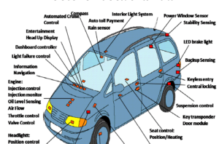](https://www.theengineeringprojects.com/wp-content/uploads/2016/11/automotive.png)

* Using embedded systems in automotive has reduced the cost factor.
* It has improved the overall performance and increased functionality.
* It has also reduced weight and made automobile more safe and reliable.
* Applications of automotive embedded systems include:
  + Automatic Stability Control
  + Traction Control System
  + Pre-crash Safety System
  + Air bag
  + Car Navigation System
* So you can see that using embedded systems in automobiles is very useful and has increased the functionality of automotive.

**Home Security System**

* In embedded systems examples, I have another interesting one on my list that is home security system.
* Home security systems are used largely today.
* These systems have several features just as checking for fire or gas leakages, and detecting if someone suspicious tries to enter the house.
* A [Microcontroller](https://www.theengineeringprojects.com/2018/03/introduction-to-microcontrollers.html) is used for controlling all the operations. Sensors give data and if something wrong happens than safety alarms get activated.
* Sensors used in such systems include gas sensors, smoke sensors, temperature sensors, IR sensors etc.
* Also a keypad is included in such systems for entering password at the gate.
* If correct password is entered then this embedded system opens the gate and if someone tries to enter wrong password than alarm is set on and gates remain closed.
* The output is received from alarms or some display.

**You should also read:**

* [10 Things for Choosing Microcontroller](https://www.theengineeringprojects.com/2016/11/10-things-for-choosing-microcontroller.html)
* [Embedded Systems Projects](https://www.theengineeringprojects.com/2016/10/embedded-system-projects.html)
* The output can also be sent to some distant location.
* If family members are not present in home then still they can monitor the activities going on in their house.
* Home security system is not limited to homes.
* Such systems can be used at shops, stores and in industries.
* Almost every industry and office has security systems that can recognize the workers from their face or identity cards.
* Home automation system is also one of the examples of embedded systems as home security system.

**Automatic Washing Machine**

* Daily life examples of embedded systems include automatic washing machines and dryers.
* Washing clothes is not a difficult task now owing to embedded systems.
* You just have to add clothes and leave it to the machine. Rest operations are done by your machine itself.
* Machines have a [Microcontroller](https://www.theengineeringprojects.com/2018/03/introduction-to-microcontrollers.html) for controlling all the tasks.
* Sensors and actuators in this case are level sensors, valves, motor and also a display and keypad to input information.
* Once you load clothes in machine, the whole process consists of three cycles. Washing, rinsing and spinning.
* All the three cycles are initiated by machine itself. You just have to enter information for hot or cold water and press start button.
* During washing and rinsing cycle, water is added to the drum by pipes.
* Closing and opening of valves for adding water is checked through level sensors by microcontroller like [PIC Microcontroller](https://www.theengineeringprojects.com/2015/03/pic-microcontroller-projects.html).
* Then the rotation of drum starts for pre-set time. After that water is drained out through pipes.
* During spinning cycle, water is not added and drum rotates for a set time.
* All the processes are controlled by microcontroller program.
* The timings for each cycle can be changed through the keypad.
* So this was another embedded systems examples. Now let’s move towards the next one.

**Personal Digital Assistant**

* Personal digital assistant (PDA) is the next example on my list. It’s a device for personal use.
* You can find a lot of personal embedded systems examples like Mobile Phones, data organizers, PDA etc.
* Personal Digital Assistant is just like a personal computer in hand. It was used before smartphones came out.
* PDA is used as information manager and has the ability to connect to internet.
* It has a display mostly touchscreen for the user to interact with the device.

[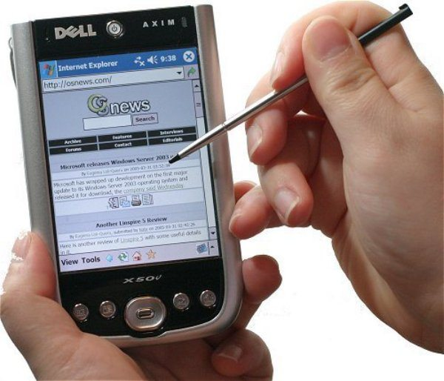](https://www.theengineeringprojects.com/wp-content/uploads/2016/11/pda.jpg)

* The display is used for entering data, memory card is used for storing data and it is provided with Bluetooth or WiFi for connectivity.
* Some of the personal digital assistants use keypads instead of touchscreen to input information.
* This device is very handy in managing and sorting personal information. It is very light in weight and serves multiple functions.
* The next example of Embedded Systems that I am going to tell you is Industrial Robots.

**Industrial Robots**

* Embedded systems have a lot of applications in industries.
* Today, every process is being taken towards automation.
* So industrial robots are very important to mention with embedded systems examples.
* An industrial robot is an embedded system that comes in a variety of forms and each performs a number of different tasks.
* Some industrial robots are used for moving parts, tools, materials etc.
* Some are used in assembly operations while some of them are used in manufacturing.
* These robots have increased the productivity.
* They are widely used where precise operations are required or at the places which are difficult to access for humans.

[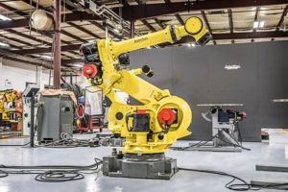](https://www.theengineeringprojects.com/wp-content/uploads/2016/11/industrial-robot.jpg)

* To understand the working of industrial robot as example of embedded systems, I am going to tell you about automated painting robots.
* Painting robots have a wide application area.
* They are replacing humans as they require less time for the whole operation and ensure best result.
* All of the activities are controlled through the program.
* Timing for the whole process and amount of paint is preset.
* Assembly robot is another example of industrial robots.
* The task of such robot is to create an assembly from all the parts.
* All parts are collected and assembled in correct sequence to form final product.
* There are a lot of examples of industrial robots.
* All are good embedded systems examples.
* Now let’s talk about another type.

**Automated Teller Machine**

* An automated teller machine (ATM) is also an embedded system.
* It is a computerized device used in banking.
* You all are already familiar with its operation and use.
* A customer can access and perform his transactions without going to the bank and meeting some assistant.
* This machine consists of a card reader for detecting card and accessing information of the person.
* Also it has a [keypad](https://www.theengineeringprojects.com/2017/08/arduino-keypad-interfacing.html) so the user can enter his commands and password.
* A screen displays information. A printer prints the receipts and cash is received from cash dispenser.
* A network is present between the bank computer and ATM machine through a host computer.
* All the data is verified with the bank computer and all transactions are stored in it.
* All these input and output operations are carried with the help of microcontroller.
* So this makes a one of the best examples of [Embedded Systems](https://www.theengineeringprojects.com/2016/10/what-is-embedded-systems.html).

**Calculator**

* [Calculator](https://www.theengineeringprojects.com/2015/12/design-simple-calculator-8051-microcontroller.html) is also one of the examples of embedded systems.
* Actually it is one of very earlier embedded system that is used widely.
* In this example, the function is to take input from the keypad, perform the required operation and show the results on LCD.
* Embedded Scientific Calculator has a high performance processor.
* A number of mathematical complex calculations can be performed by these calculators.
* You can also program such scientific calculators.
* With such kind of functionality, these calculators are very advance as compared to simple calculators, all because of embedded systems.

Examples of embedded systems are numerous and it is hard to discuss all of them here. Embedded Systems are used in different fields like:

* Automobiles
* Aerospace
* Telecommunication
* Consumer Electronics
* Banking
* Homes
* Offices
* [Security Control](https://www.theengineeringprojects.com/product/security-control-system-using-xbee-gsm-proteus)
* Academia

Some other examples include:

* Anti-lock brakes.
* Auto-focus camera.
* Teller machines.
* Automatic toll systems.
* Automatic transmission.
* Elevators
* [Power Suppliers](https://www.theengineeringprojects.com/2015/04/how-to-design-a-dc-power-supply-in-proteus.html)
* Avionic systems etc.

Here I have compiled few examples of Embedded Systems in a single image below and yyou can see in this image that we are slaves of [Embedded Systems](https://www.theengineeringprojects.com/2016/10/embedded-system-projects.html). 🙂

[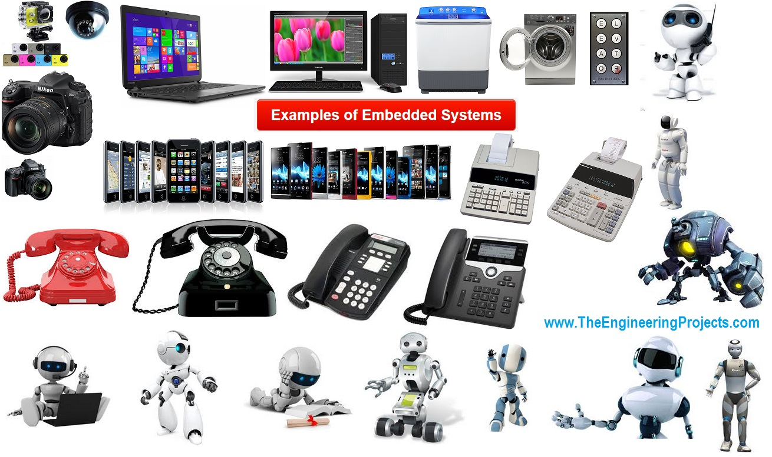](https://www.theengineeringprojects.com/wp-content/uploads/2016/11/Examples-of-Embedded-Systems.jpg)That was all from my side, I hope you will enjoy reading these Examples of Embedded Systems and if you don’t find any Embedded Systems Examples in above list then you can share it in comments below and I will add it up. So, stay blessed and have fun. Take Care !!! 🙂

Get an instant access to your all-time favorite files, media remotely from anywhere with [citrix hosted applications](https://www.clouddesktoponline.com/citrix-xen-desktop/) with 24*7 excellent tech-support from one of the best DaaS provider – [Apps4Rent.com](http://www.apps4rent.com/)

[**JLCPCB - Prototype 10 PCBs for $2 + 2 days Lead Time**](https://jlcpcb.com/)  
[China's Largest PCB Prototype Enterprise, 300,000+ Customers & 10,000+ Online Orders Per Day](https://jlcpcb.com/)  
[Get quote online easily: https://jlcpcb.com](https://jlcpcb.com/quote)

Category: [Embedded Systems](https://www.theengineeringprojects.com/category/embedded-systems)[By Syed Zain Nasir](https://www.theengineeringprojects.com/author/theenggprojects)[November 12, 2016](https://www.theengineeringprojects.com/2016/11/12)[12 Comments](https://www.theengineeringprojects.com/2016/11/examples-of-embedded-systems.html#comments)



**Author: Syed Zain Nasir**

I am Syed Zain Nasir, the founder of [The Engineering Projects](https://www.TheEngineeringProjects.com/) (TEP). I am a programmer since 2009 before that I just search things, make small projects and now I am sharing my knowledge through this platform.I also work as a freelancer and did many projects related to programming and electrical circuitry. [My Google Profile+](https://plus.google.com/+SyedZainNasir/)

**Post navigation**

[PreviousPrevious post:6 Necessary Embedded Tools](https://www.theengineeringprojects.com/2016/11/necessary-embedded-tools.html)[NextNext post:10 Things for Choosing Microcontroller](https://www.theengineeringprojects.com/2016/11/10-things-for-choosing-microcontroller.html)

**12 Comments**

1. https://secure.gravatar.com/avatar/cdae1fa468863281b5d1b471df2c345b?s=60&d=mm&r=gMohamed says:

[November 12, 2016 at 2:13 pm](https://www.theengineeringprojects.com/2016/11/examples-of-embedded-systems.html#comment-12059)

This series of embedded systemes courses, i study mechatronics in university and your site halped me alot especialy this series.. i hope you keep this grate job,  
Thank you so much for.

[Reply](https://www.theengineeringprojects.com/2016/11/examples-of-embedded-systems.html#comment-12059)

* + https://secure.gravatar.com/avatar/8f1106e40e09f8d92785b3db40f7c163?s=60&d=mm&r=gSyed Zain Nasir says:

[May 12, 2018 at 1:12 am](https://www.theengineeringprojects.com/2016/11/examples-of-embedded-systems.html#comment-156585)

Thanks for the appreciation and you are most welcome. 🙂

[Reply](https://www.theengineeringprojects.com/2016/11/examples-of-embedded-systems.html#comment-156585)

1. Khan says:

[July 11, 2017 at 2:20 pm](https://www.theengineeringprojects.com/2016/11/examples-of-embedded-systems.html#comment-74677)

This article is very useful. Thank you for the article.

[Reply](https://www.theengineeringprojects.com/2016/11/examples-of-embedded-systems.html#comment-74677)

1. Fatima says:

[October 17, 2017 at 4:05 pm](https://www.theengineeringprojects.com/2016/11/examples-of-embedded-systems.html#comment-146405)

Thanks for this article … It helped me a lot …  
So Thanks❤❤❤❤

[Reply](https://www.theengineeringprojects.com/2016/11/examples-of-embedded-systems.html#comment-146405)

1. laxmi says:

[November 22, 2017 at 2:42 pm](https://www.theengineeringprojects.com/2016/11/examples-of-embedded-systems.html#comment-149684)

it’s good information about embedded system.now i understand scope of it.but what is salary get after this course????  
thank you.

[Reply](https://www.theengineeringprojects.com/2016/11/examples-of-embedded-systems.html#comment-149684)

1. hasna says:

[December 6, 2017 at 12:58 am](https://www.theengineeringprojects.com/2016/11/examples-of-embedded-systems.html#comment-149954)

thank you for giving me the information about embeded system ……..  
i want to get some examples of embedded system in agricultural field

[Reply](https://www.theengineeringprojects.com/2016/11/examples-of-embedded-systems.html#comment-149954)

1. hasna says:

[December 6, 2017 at 1:53 pm](https://www.theengineeringprojects.com/2016/11/examples-of-embedded-systems.html#comment-149974)

Thank you for giving me more information about embedded system

[Reply](https://www.theengineeringprojects.com/2016/11/examples-of-embedded-systems.html#comment-149974)

1. Yogesh S says:

[January 28, 2018 at 8:42 am](https://www.theengineeringprojects.com/2016/11/examples-of-embedded-systems.html#comment-152640)

Great article!

[Reply](https://www.theengineeringprojects.com/2016/11/examples-of-embedded-systems.html#comment-152640)

1. Vivek says:

[January 29, 2018 at 8:43 am](https://www.theengineeringprojects.com/2016/11/examples-of-embedded-systems.html#comment-152667)

Useful article.

[Reply](https://www.theengineeringprojects.com/2016/11/examples-of-embedded-systems.html#comment-152667)

1. Winnielove says:

[February 27, 2018 at 3:33 am](https://www.theengineeringprojects.com/2016/11/examples-of-embedded-systems.html#comment-153615)

Thanks for the article. It has made me understand it in a very simple way

[Reply](https://www.theengineeringprojects.com/2016/11/examples-of-embedded-systems.html#comment-153615)

1. Priya says:

[June 7, 2018 at 4:28 pm](https://www.theengineeringprojects.com/2016/11/examples-of-embedded-systems.html#comment-158164)

Can you help me in figuring out the analyzing of interfaces of any two embedded systems that are available now a days in market?

[Reply](https://www.theengineeringprojects.com/2016/11/examples-of-embedded-systems.html#comment-158164)

* + https://secure.gravatar.com/avatar/8f1106e40e09f8d92785b3db40f7c163?s=60&d=mm&r=gSyed Zain Nasir says:

[June 22, 2018 at 4:20 pm](https://www.theengineeringprojects.com/2016/11/examples-of-embedded-systems.html#comment-158844)

Hi,

It depends on the nature of your Embedded systems, if I could understand then I will try to help. Let me know the details.

Thanks.

[Reply](https://www.theengineeringprojects.com/2016/11/examples-of-embedded-systems.html#comment-158844)

**Leave a Reply**

Top of Form

Your email address will not be published. Required fields are marked *

Comment

Name * Email * Website

Save my name, email, and website in this browser for the next time I comment.

[Post comment](javascript:void(0);)

Bottom of Form

This site uses Akismet to reduce spam. [Learn how your comment data is processed](https://akismet.com/privacy/).

Top PCB Design Services

[](https://jlcpcb.com/)

[](https://www.wellpcb.com/)

[](https://www.pcbgogo.com/)

Subscribe Now !!!

[https://feeds.feedburner.com/~fc/theengineeringprojects?bg=f2f2f2&fg=666&anim=1](https://feeds.feedburner.com/theengineeringprojects)Learn Free Pro Tricks

[RSS](https://feeds.feedburner.com/theengineeringprojects)

[G+](https://plus.google.com/+SyedZainNasir)

[FB](https://www.facebook.com/theengineeringprojects)

[Tw](https://twitter.com/syedzainnasir)

Receive Quality Tutorials Straight in your    Inbox by submitting your Email ID below.

Top of Form



Bottom of Form

Join Us !!!

|  |  |
| --- | --- |
| [*23871 Likes*](https://www.facebook.com/theengineeringprojects) | [*659 Followers*](https://plus.google.com/+SyedZainNasir/) |
| [*453 Followers*](https://twitter.com/syedzainnasir) | [*251 Subscribers*](https://www.youtube.com/channel/UCbVgl6VOoqgq8FalMq6vikw) |
| [*497 Connections*](https://www.linkedin.com/in/zainnasir) | [*2727 Followers*](https://feeds.feedburner.com/theengineeringprojects) |
| [*497 Followers*](https://www.pinterest.com/zainnasir/) | [*2727 Followers*](https://www.instagram.com/nasirsyedzain/) |

Join Our Facebook Groups !!!

|  |  |
| --- | --- |
| [*2862 Arduino*](https://www.facebook.com/groups/ArduinoTEP/) | [*6904 Proteus*](https://www.facebook.com/groups/ProteusISIS) |

Categories

* [Arduino Projects](https://www.theengineeringprojects.com/2015/03/arduino-projects.html)
* [Proteus Projects](https://www.theengineeringprojects.com/2013/03/a-complete-tutorial-on-how-to-use-proteus-isis-ares.html)
* [PIC Projects](https://www.theengineeringprojects.com/2015/03/pic-microcontroller-projects.html)
* [Visual Studio Projects](https://www.theengineeringprojects.com/microsoft-visual-studio-2010-tutorials)
* [8051 Projects](https://www.theengineeringprojects.com/2016/01/8051-microcontroller-projects.html)
* [555 Timer Projects](https://www.theengineeringprojects.com/2016/02/555-timer-projects.html)
* [MATLAB Projects](https://www.theengineeringprojects.com/2016/02/matlab-projects.html)
* [LabView Projects](https://www.theengineeringprojects.com/2016/05/labview-projects.html)
* [PLC Projects](https://www.theengineeringprojects.com/2016/05/plc-projects.html)
* [Electronics Projects](https://www.theengineeringprojects.com/2016/02/electronics-projects.html)
* [C# Tutorials](https://www.theengineeringprojects.com/2016/05/tutorial.html)
* [Embedded System Projects](https://www.theengineeringprojects.com/2016/10/embedded-system-projects.html)

Advertisement

[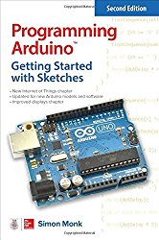](https://www.amazon.com/gp/product/1259641635/ref=as_li_tl?ie=UTF8&camp=1789&creative=9325&creativeASIN=1259641635&linkCode=as2&tag=tep027-20&linkId=e6c7f47e9fa7493e760c9e2f5d31e9cd)https://ir-na.amazon-adsystem.com/e/ir?t=tep027-20&l=am2&o=1&a=1259641635

Recent Posts

* [How to Write SEO Friendly Blog Post Titles?](https://www.theengineeringprojects.com/2018/07/how-to-write-seo-friendly-blog-post-titles.html) July 6, 2018
* [What is Meta Description? Steps to Write Killer Meta Description for SEO](https://www.theengineeringprojects.com/2018/07/what-is-meta-description-steps-write-killer-meta-description.html) July 5, 2018
* [Social Share Counter by TEP](https://www.theengineeringprojects.com/2018/07/social-share-counter-by-tep.html) July 2, 2018
* [Introduction to Arduino Mega 2560](https://www.theengineeringprojects.com/2018/06/introduction-to-arduino-mega-2560.html) June 30, 2018
* [How to Select Best Blast Door for My Project?](https://www.theengineeringprojects.com/2018/06/how-to-select-best-blast-door-for-my-project.html) June 29, 2018

Get in Touch !!!

Top of Form

Name * E-mail *

Message

[Submit](https://www.theengineeringprojects.com/2016/11/examples-of-embedded-systems.html)

Bottom of Form

Contact Info !!!

* Address:  
  825, Al-Hafeez Shopping Mall, Main-Boulevard, Gulberg.
* Phone Number:  
  +92-300-4711820
* E-mail:  
  info@theengineeringprojects.com support@theengineeringprojects.com help@theengineeringprojects.com

Find us on:

[Facebook](https://www.facebook.com/theengineeringprojects)[Twitter](https://twitter.com/syedzainnasir)[Google+](https://plus.google.com/+SyedZainNasir/)[YouTube](https://www.youtube.com/theengineeringprojects)

[](https://www.theengineeringprojects.com/)

The Engineering Projects - Tutorials & Projects for Engineers.

[Go to Top](https://www.theengineeringprojects.com/2016/11/examples-of-embedded-systems.html)

[](https://www.theengineeringprojects.com/)

* [Home](https://www.theengineeringprojects.com/)
* [Blog](https://www.theengineeringprojects.com/blog)
* [Forum](https://www.theengineeringprojects.com/forum/)
* [Projects](https://www.theengineeringprojects.com/2015/03/arduino-projects.html)
* [JLCPCB $2 PCBs](https://jlcpcb.com/)
* [Free PCB](https://www.pcbway.com/free_pcb.html?ad=TEP)
* [PCB Online-Ordering](https://www.wellpcb.com/pcb-quote)

Top of Form

Search: [Search](https://www.theengineeringprojects.com/2016/11/examples-of-embedded-systems.html#go)

Bottom of Form

|  |  |  |
| --- | --- | --- |
| https://ssl.gstatic.com/s2/oz/images/stars/po/bubblev1/border_3.gif | https://ssl.gstatic.com/s2/oz/images/stars/po/bubblev1/spacer.gif | https://ssl.gstatic.com/s2/oz/images/stars/po/bubblev1/border_3.gif |
| https://ssl.gstatic.com/s2/oz/images/stars/po/bubblev1/spacer.gif | https://ssl.gstatic.com/s2/oz/images/stars/po/bubblev1/spacer.gif | https://ssl.gstatic.com/s2/oz/images/stars/po/bubblev1/spacer.gif |
| https://ssl.gstatic.com/s2/oz/images/stars/po/bubblev1/spacer.gif |  | https://ssl.gstatic.com/s2/oz/images/stars/po/bubblev1/spacer.gif |
| https://ssl.gstatic.com/s2/oz/images/stars/po/bubblev1/border_3.gif | |  |  | | --- | --- | | https://ssl.gstatic.com/s2/oz/images/stars/po/bubblev1/spacer.gif | https://ssl.gstatic.com/s2/oz/images/stars/po/bubblev1/spacer.gif | | https://ssl.gstatic.com/s2/oz/images/stars/po/bubblev1/spacer.gif |

AddThis Sharing Sidebar

Share to Google BookmarkShare to FacebookShare to TwitterShare to PrintShare to EmailShare to PinterestShare to GmailShare to Google+Share to LinkedInMore AddThis Share options

2K

SHARES

:)